EL PASO COUNTY

4-H NEWS
October 2020

El Paso County Staff
Felicia Martinez
CEA 4-H & Youth Development Felicia.martinez@ag.tamu.edu

Orlando Flores
CEA – Ag & NR
ooflores@ag.tamu.edu

Gigi Shamaley, Ph.D.
CEA – FCH
Angelee.shamaley@ag.tamu.edu

Madelynne Cera
CEP 4-H & Youth Development
Madelynne.cera@ag.tamu.edu

Denise Rodriguez County Extension Director drodriguez@ag.tamu.edu

El Paso County Office
201 Manny Martinez Dr El Paso, TX 79905

(915) 771-2354
elpaso@ag.tamu.edu

elp.tamu.edu

4-H Enrollment is OPEN!!
September 1st kicked off the beginning of the 2020-2021 4-H year. All previously enrolled 4-H members and volunteers/adults will need to re-enroll as your account is now listed as inactive. You must be an active member to participate in workshops, contests, and shows from now until October 31st the enrollment fee is $25 per youth. After that date the fee increases to $30 we are happy to send you step by step instructions on how to enroll on 4-H connect
El Paso County 4-H is open to all 3rd - 12th graders living in El Paso County or attending a school in El Paso County. Families with younger children (k-2nd grade), can a role as a Clover kid for free. Clover kids may participate in meetings in some County level events. Adults can enroll as a volunteer for
$10 (some contests require adult coaches to enroll through for each connect requiring an active profile).
Call the office today with any enrollment questions or 4-H inquiries!

INSIDE THIS ISSUE

facebook.com/ElPasoCounty4h

Major Livestock Shows Quality Counts Recordbook Workshop Local Events
Major Entry Night

Paper Clover Fundraiser Calendar

Page 2

Stay connected with Texas 4-H:

https://texas4- h.tamu.edu/

texas4h Texas4h

Texas4h tx4h Newsletter

El Paso County 4-H News

Spring 2021 Major Livestock Shows
Jan 15 – Feb 6
https://www.fwssr.com/p/livestock-shows/livestock- premium-list
Feb 4 – 21
https://www.sanangelorodeo.com/p/livestock1/entries- premiumbook
Feb 11 – 28
https://www.sarodeo.com/livestock/livestock- premium-list

Feb 12-14
https://www.texaseliteshowcase.com

Mar 2 – 21
https://www.rodeohouston.com/Get- Involved/Exhibitors-Participants/Livestock-Show
Mar 12 – 27
https://rodeoaustin.com/youth-ag- programs/competitions/livestock-show/

If you are entering the 3rd, 6th, or 9th grade this fall or you are new to 4-H, you must take (or re-take) the Quality Counts course to show your livestock project! This course must be completed by the Entry Deadline of the show you are planning to attend.
https://www.texaslivestockvalidation.com/qc/qcregister.aspx

El Paso County 4-H News Page 3

WORKSHOPS
Fall Recordbook Training
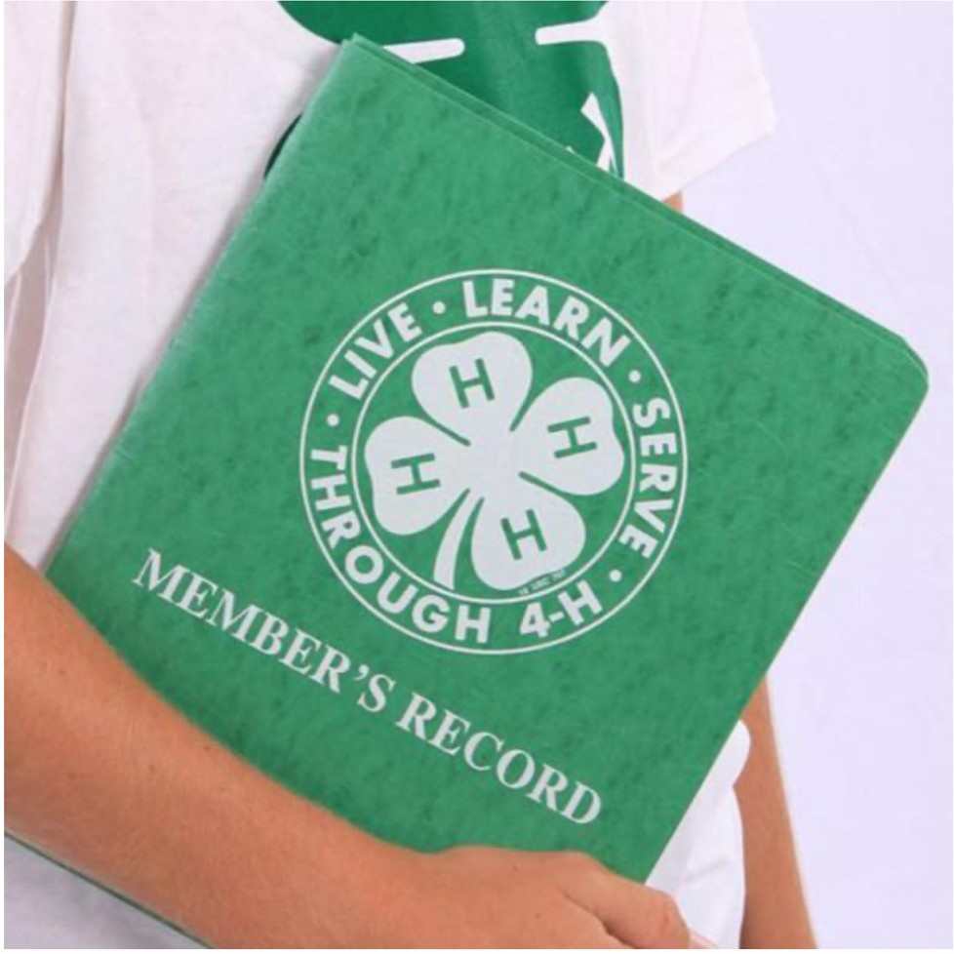
Get a headstart on your Recordbook this Fall

When: Tuesday October
28, 5:30pm

Where: Zoom
This training will begin by covering general Recordbook information to include ZSuites Online Recordbook. A Recordbook can be split into 2 main parts – 1. Story & Photo Portfolio and 2. Report Forms. We will focus on Part 1. Story & Photo Portfolio. A second workshop highlighting the report forms will follow in the spring.

2020 – 2021 Resources: Recordbook Family Guide Recordbook Categories Recordbook Report Forms

Page 4 El Paso County 4-H News

El Paso County 4-H News Page 5

MAJOR SHOW ENTRY NIGHT
Tuesday, November 10
4:00 – 8:00 pm
Where: Zoom
One-stop-shop of entries!

HAVE COMPLETE: Quality Counts course &
4-H
Enrollment

Each Spring and Fall, Tractor Supply Company will help raise money for 4-H programs with the paper Clover campaign, a national in-store fundraiser that benefits for H programming.

2020 4-H paper Clover FALL 10/7 – 10/18

You can contribute during our fall 2020 fundraiser by:
- Donating in store at the cash register.
- Donating online at checkout when making a purchase on https://www.tractorsupply
.com (Donations will be assigned to states based on the shipping location).

Page 6

El Paso County 4-H News

El Paso County Staff  Felicia Martinez  CEA 4-H & Youth Development Felicia.martinez@ag.tamu.edu  Orlando Flores  CEA – Ag & NR  ooflores@ag.tamu.edu  Gigi Shamaley, Ph.D.  CEA – FCH  Angelee.shamaley@ag.tamu.edu  Madelynne Cera  CEP 4-H & Youth Development Madelynne.cera@ag.tamu.edu  Luz Waters  CEA – Expanded Food & Nutrition Education Program Luz.waters@ag.tamu.edu  Joel Arce  IPM  Joel.arce@ag,tamu.edu  Lorena Iverson  BLT  liverson@ag.tamu.edu  Andrea Everett CEP- Community & Ec. Development  Andie.everett@ag.tamu.edu  Denise Rodriguez County Extension Director drodriguez@ag.tamu.edu  El Paso County Office  201 Manny Martinez Dr El Paso, TX 79905  (915) 771-2354  elpaso@ag.tamu.edu  elp.tamu.edu  facebook.com/ElPasoCounty4h | How are you staying in touch?  Did you know…?  …we have a Facebook?  @ElPasoCounty4H is one of the best ways to stay connected with what El Paso 4-H is doing and related 4-H events across all project areas. The most recent and current updates from livestock shows and related pages are shared directly to our FB  page. El Paso County 4-H events are kept updated, as well as posting related events in the FB albums. Newsletters and rulebooks are also uploaded as pictures!  …the newsletter is on 4-H Connect?  When logging on to 4-H Connect, our monthly newsletter is posted on the homepage as well as the previous month’s newsletter!  …we have an El Paso County AgriLife Website?  You can find enrollment information, livestock show links, camp information, county show rulebook, youth fair entry forms and rulebook, recordbook information, and 4-H projects and related activities/contests?  https://elp.tamu.edu/4-h-and-youth-development/
 | El Paso County 4-H Calendar of Events
 | Events | Dates
 | National 4-H Week | Oct 4-10
 | Tractor Supply Company Paper Clover Campaign | Oct 7-18
 | Texas 4-H Shooting Sports Ambassador Training | Oct 23-25
 | Fall Recordbook Training | 28-Oct
 | Major Show Entry Night | 10-Nov
 | Junior Leadership Retreat (in Brownwood, Tx) | Nov 13 -15

